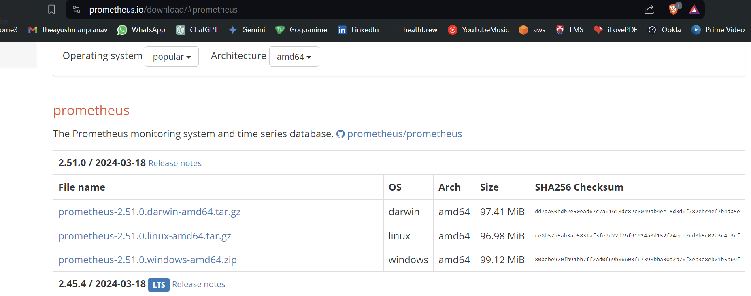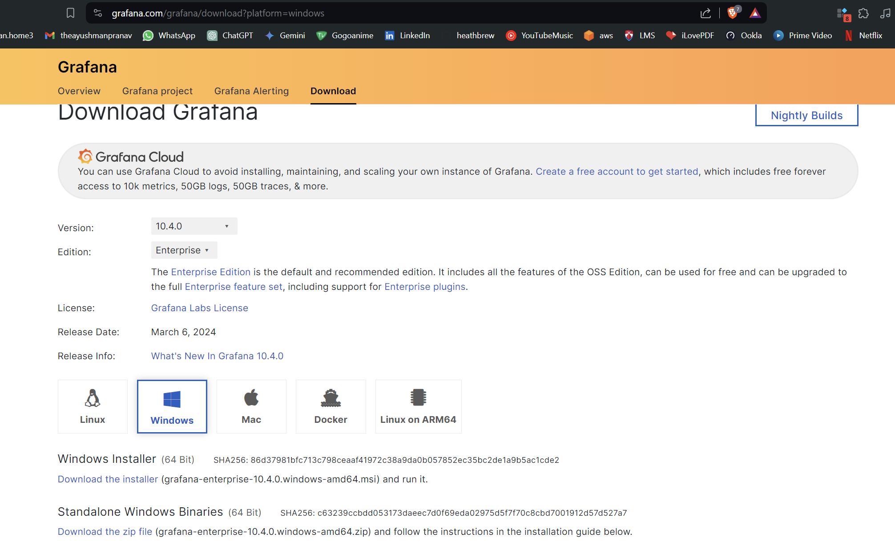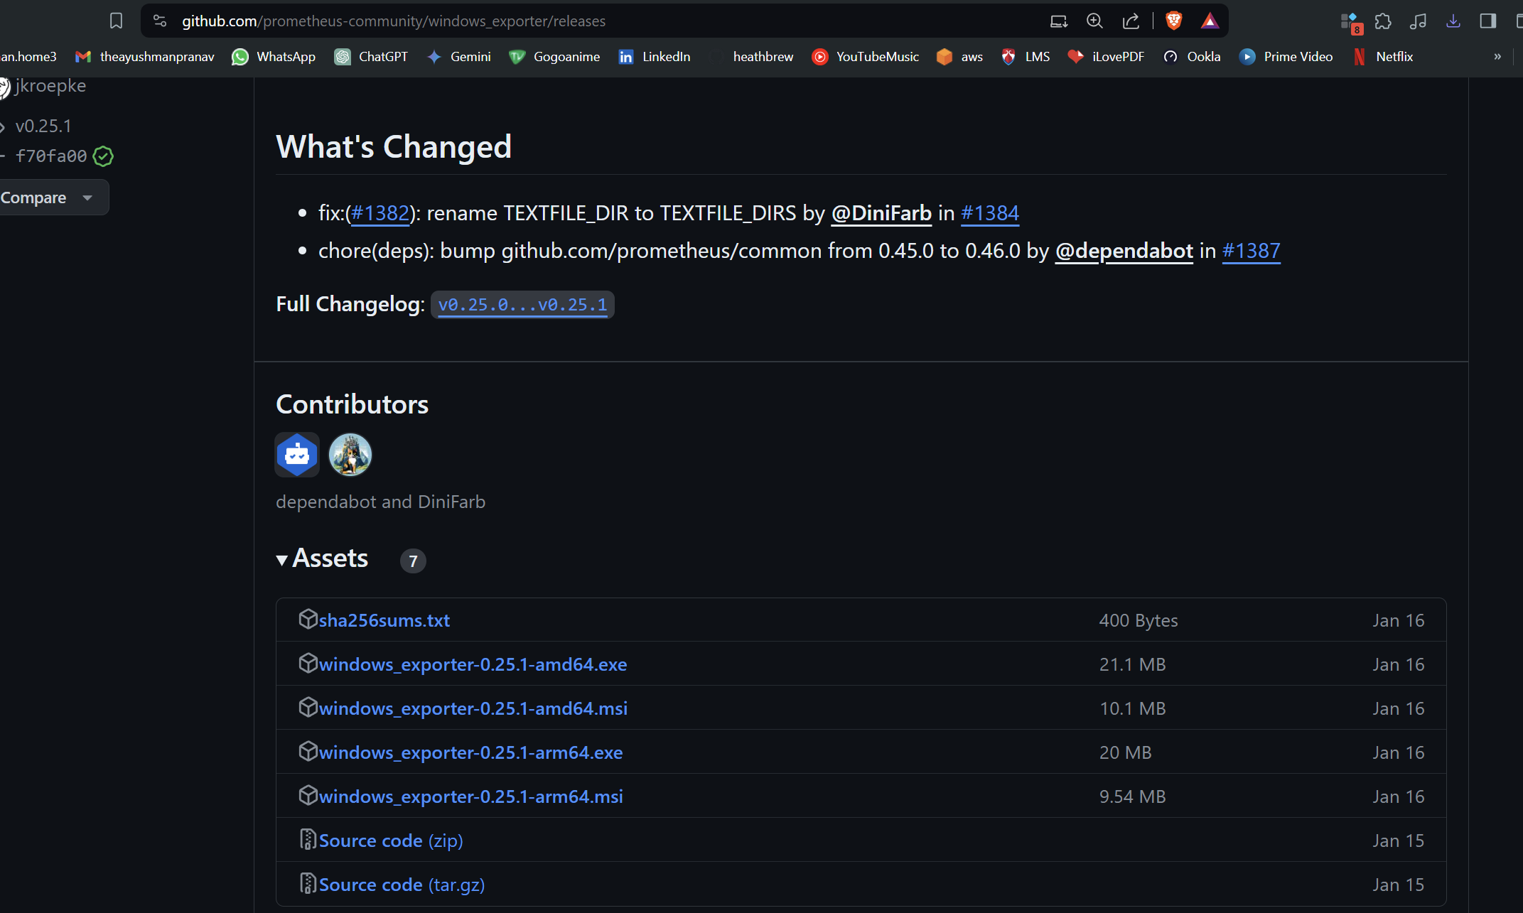

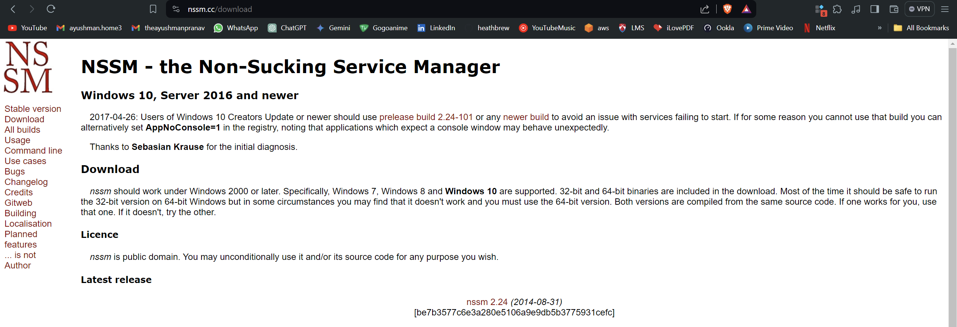

## Grafna installation

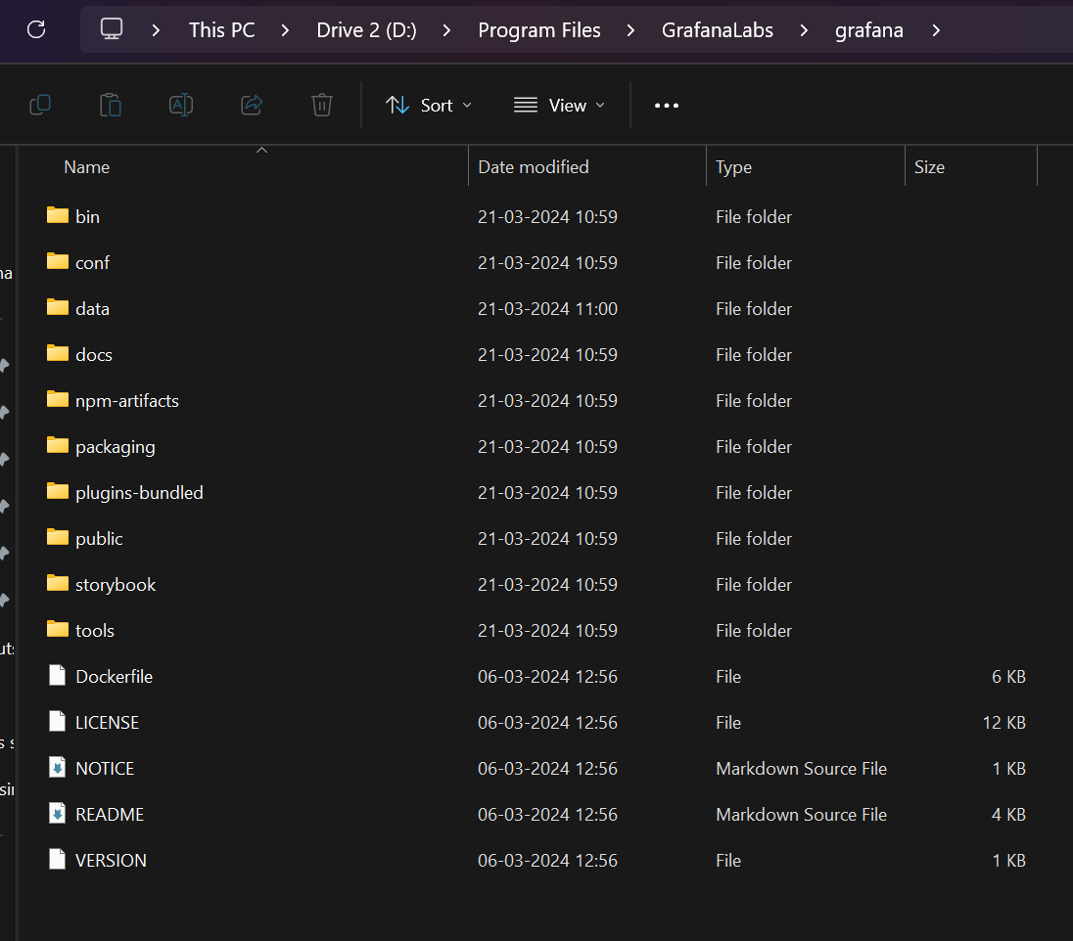

Go to config and then search for smtp

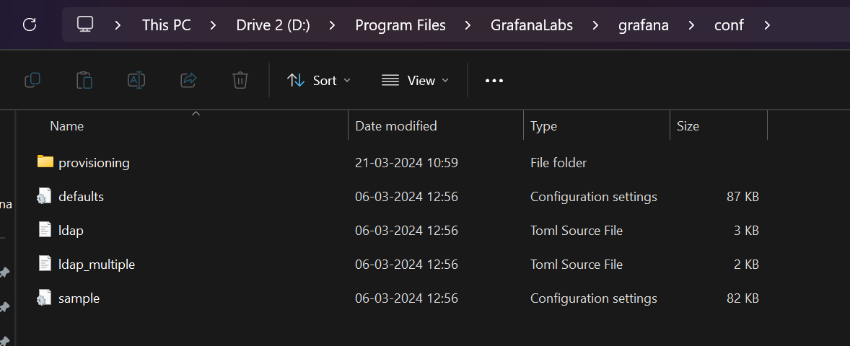  
open defaults

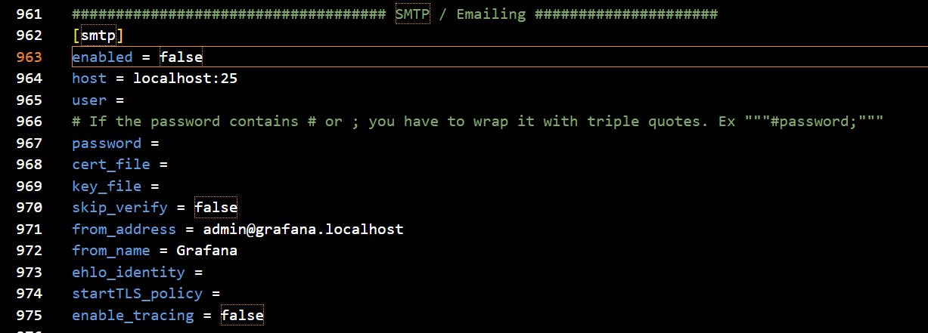

Switch enabled to true

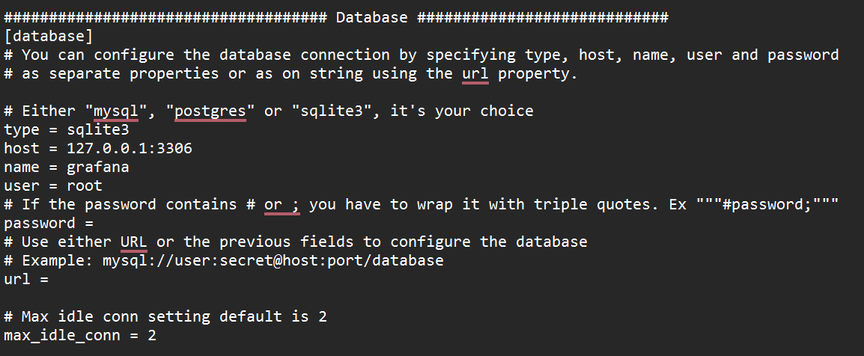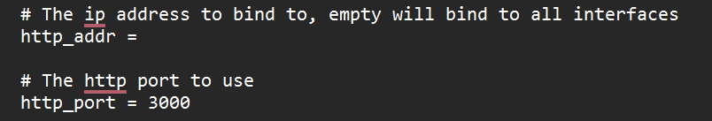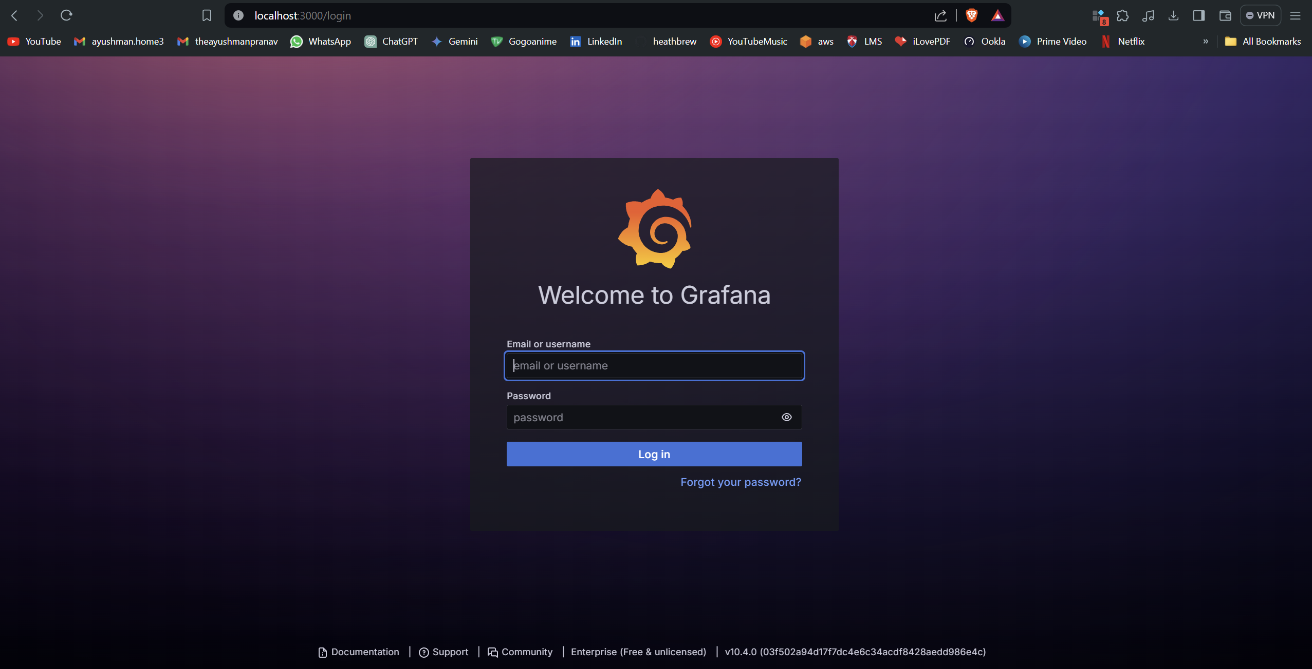 the default username and pass word is admin

After logging in   
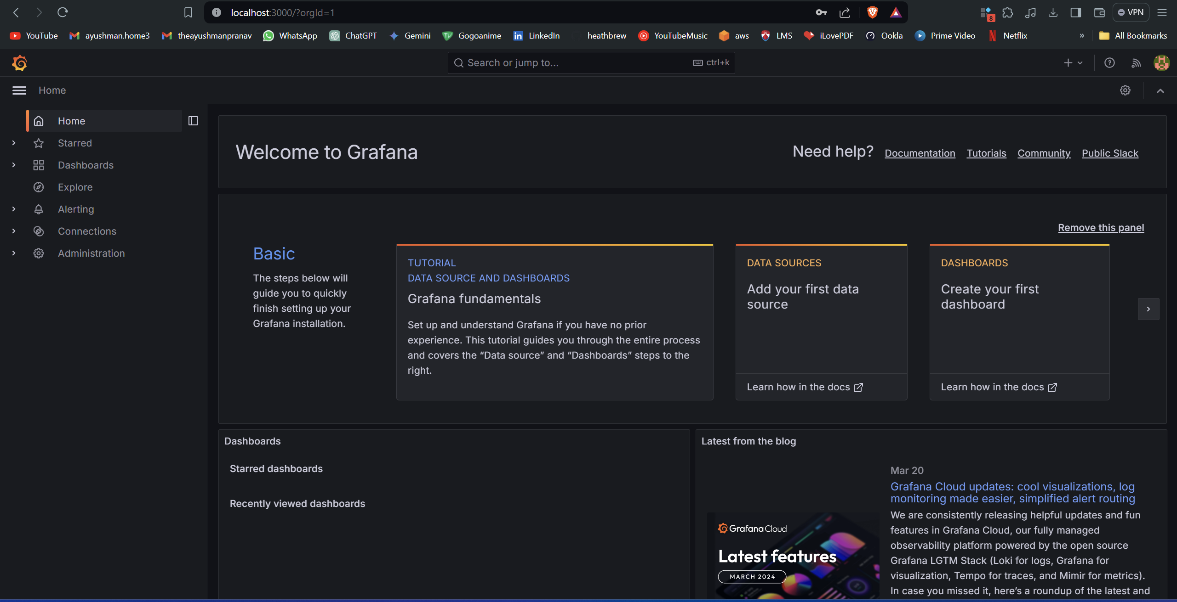

## Prometheus installation using NSSM

Got to the location of NSSM

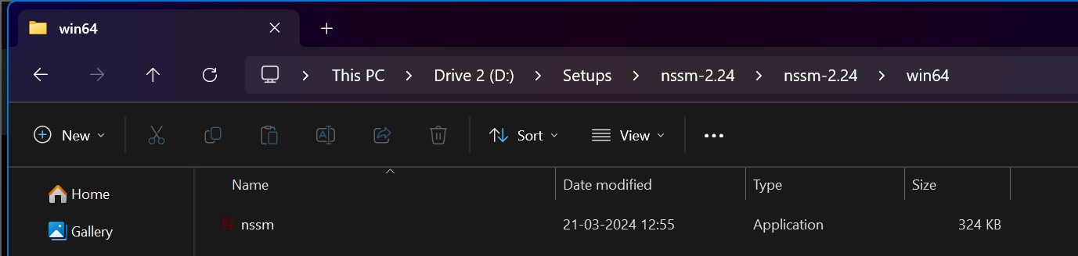

Copy the path of this folder

**D:\Setups\nssm-2.24\nssm-2.24\win64**

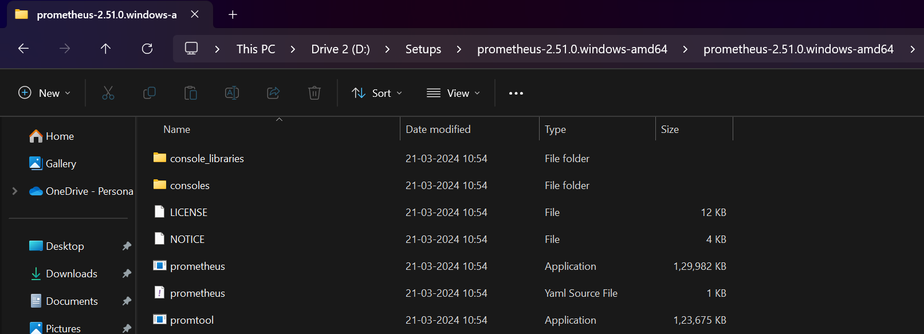

**Path of the prometheus**

**D:\Setups\prometheus-2.51.0.windows-amd64\prometheus-2.51.0.windows-amd64\prometheus.exe**

Open the command prompt in administrator mode

Cd into this path

Now we will prepare this command

nssm.exe install prometheus < path of prometheus.exe>

so now the command comes out to be

**.\nssm.exe install prometheus "D:\Setups\prometheus-2.51.0.windows-amd64\prometheus-2.51.0.windows-amd64\prometheus.exe"**

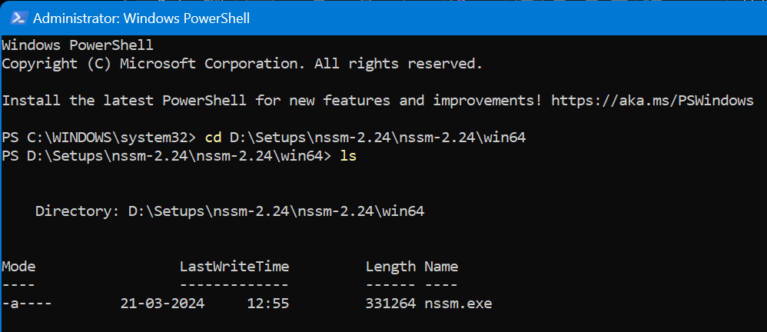



**To permanently activate we need windows exporter**

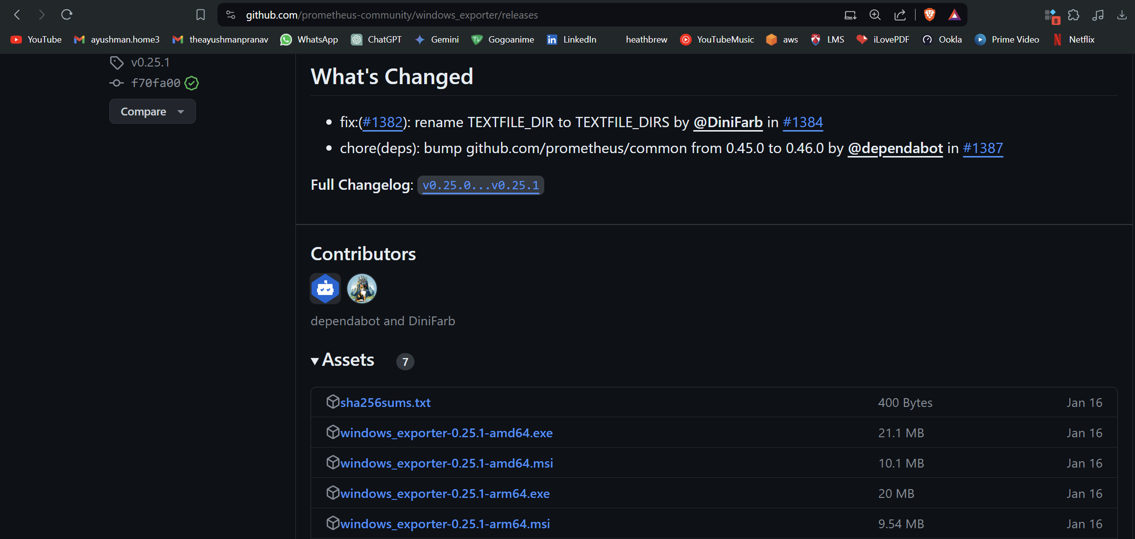

**Download**



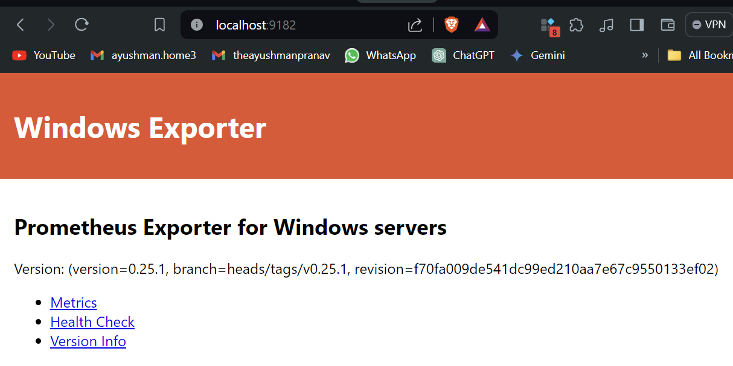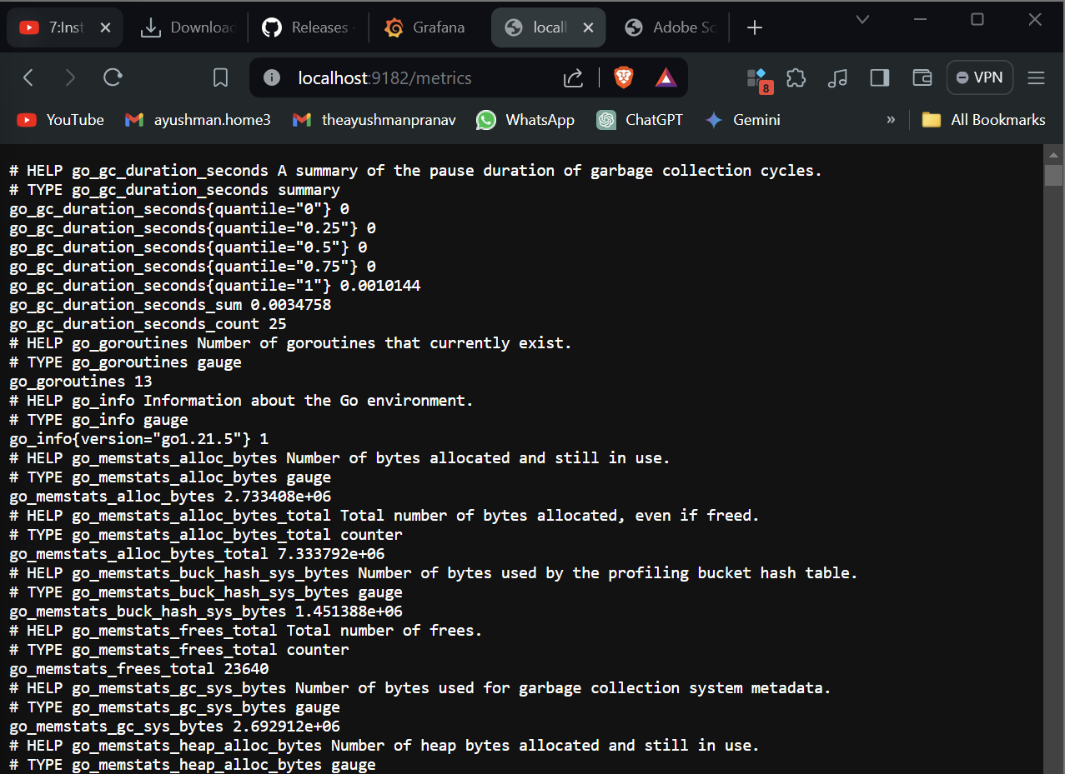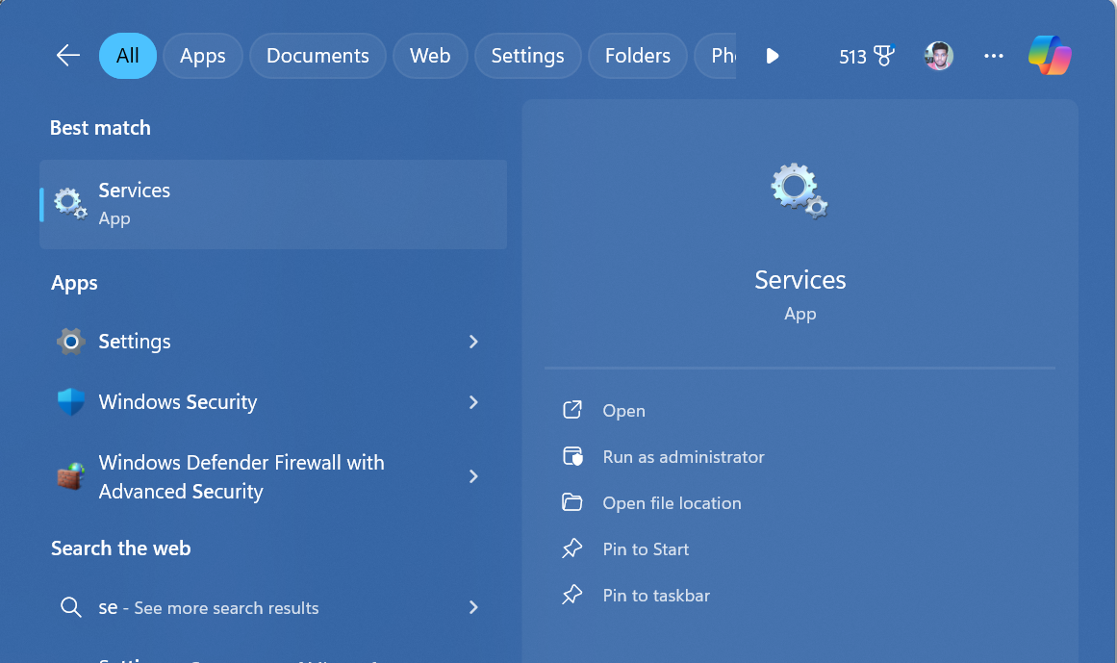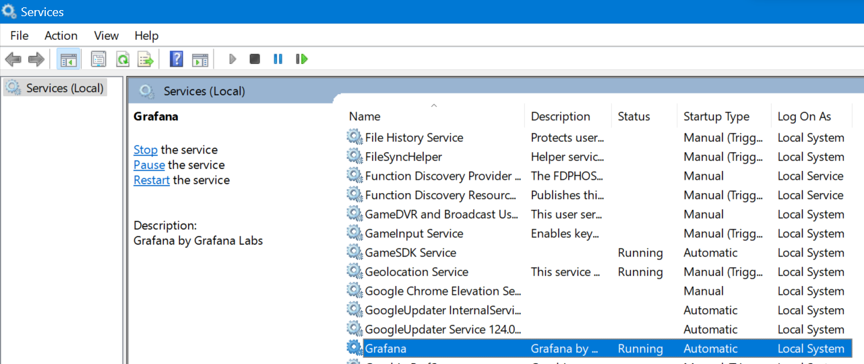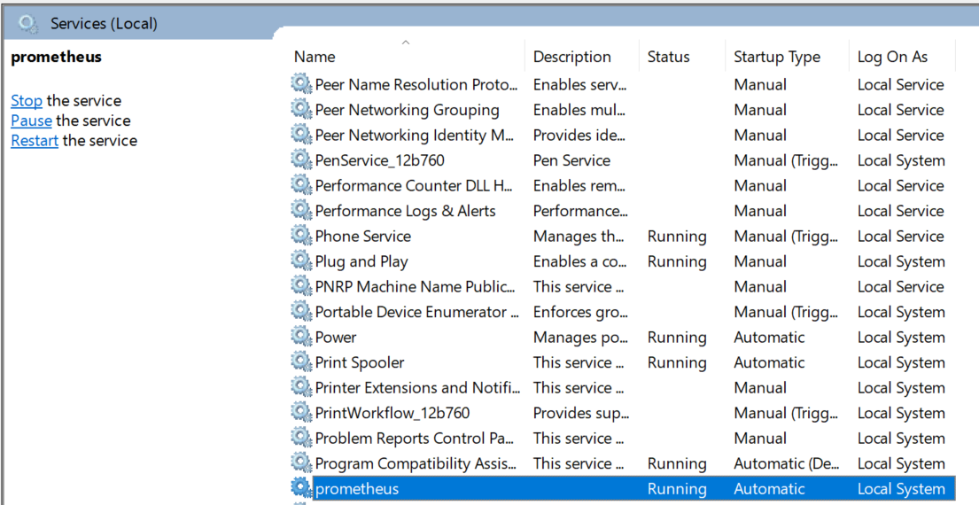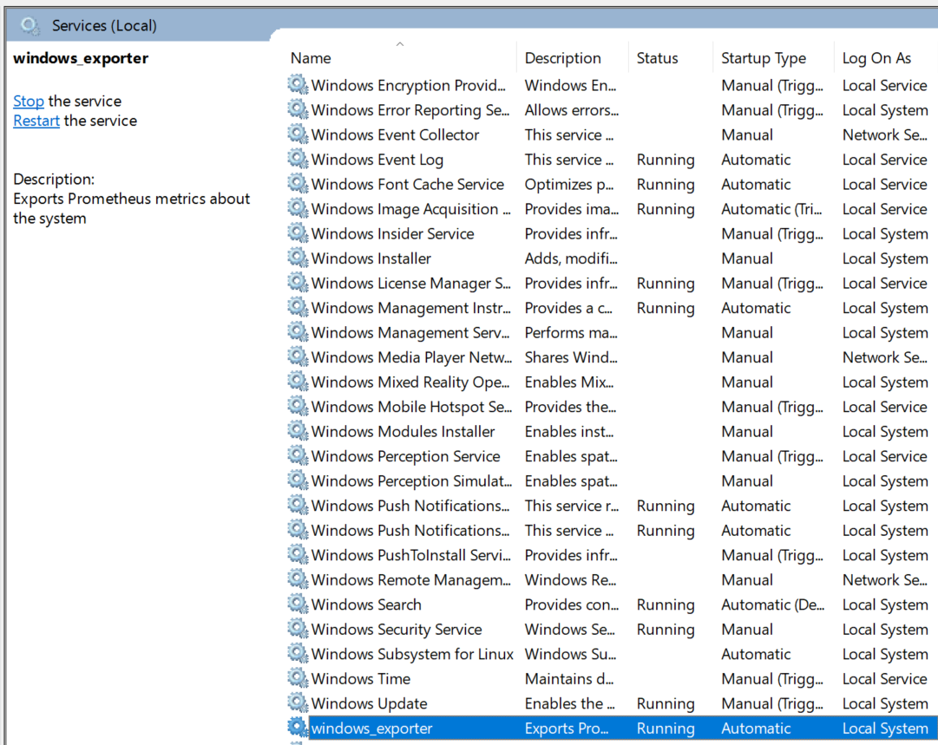

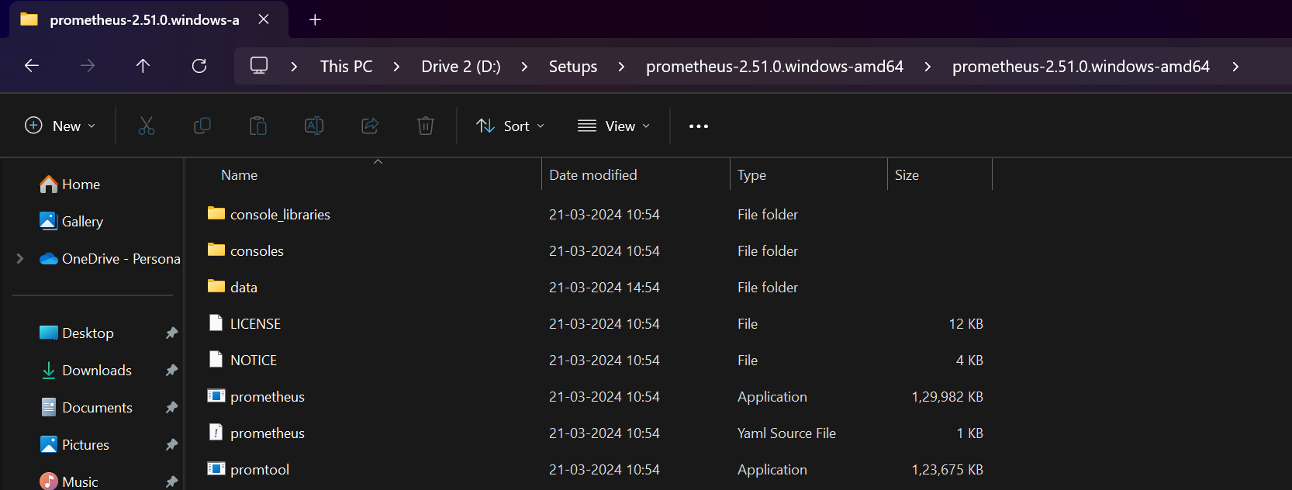

**Go to Prometheus.yml**

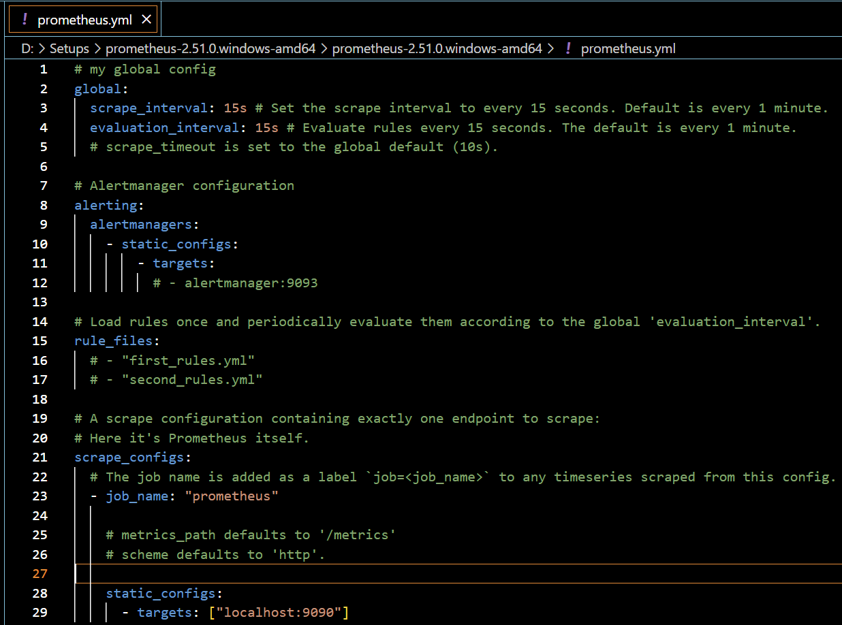**add windows exporter**

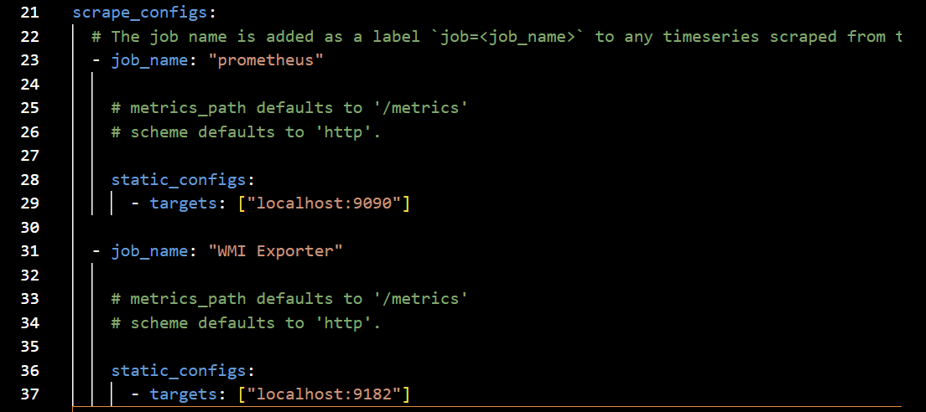



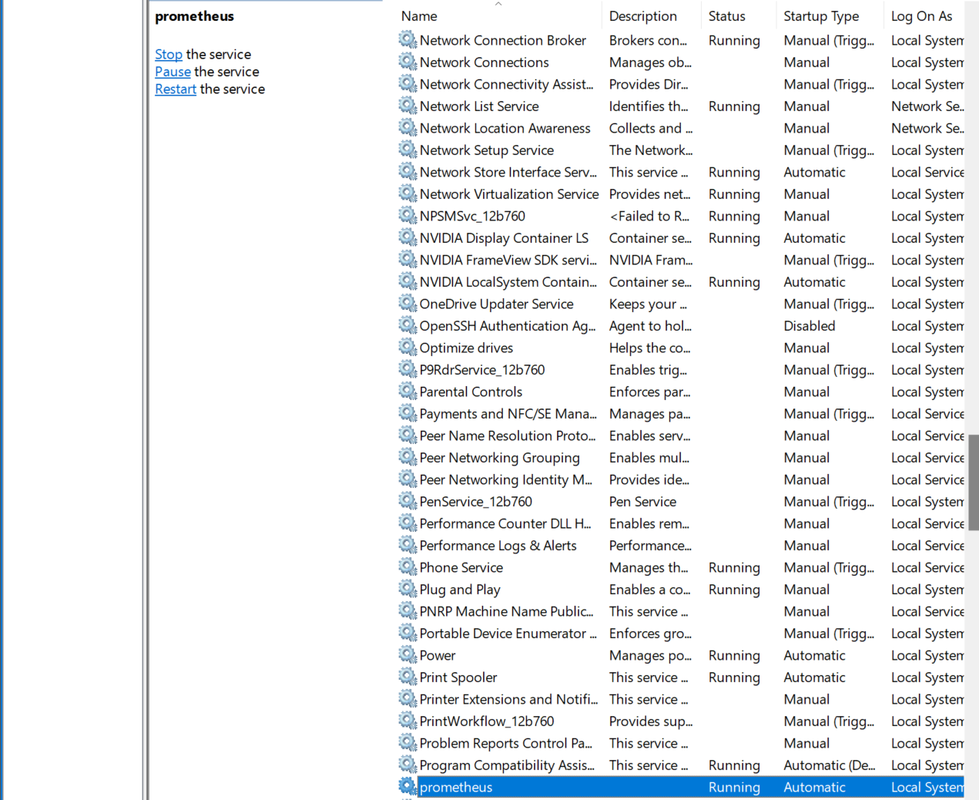

**Restart the Prometheus service**

**Check localhost:9090**

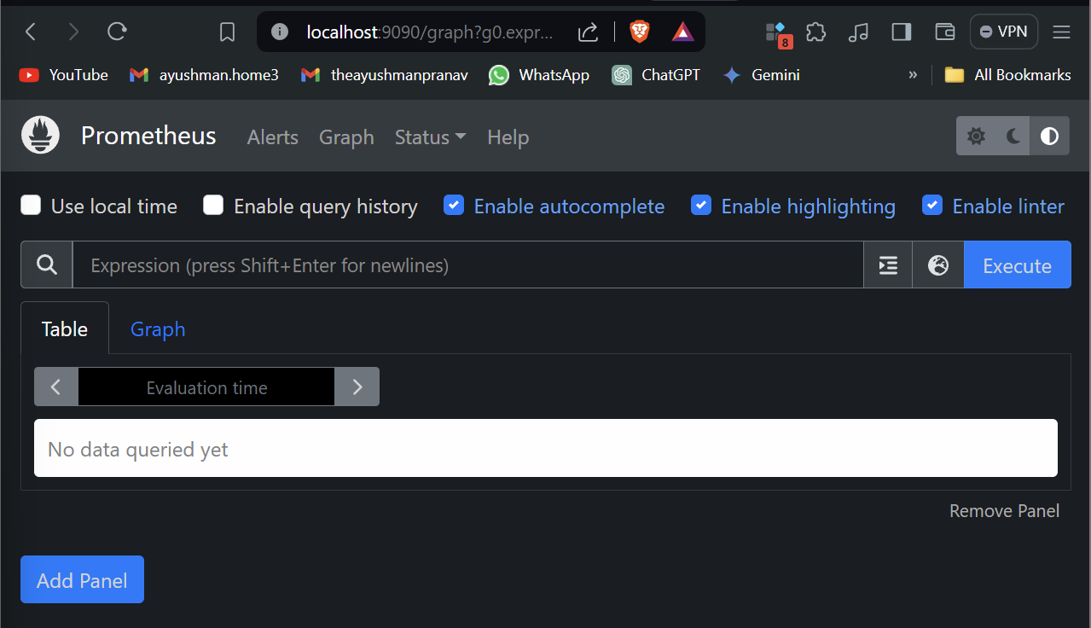

**Welcome the Prometheus UI**

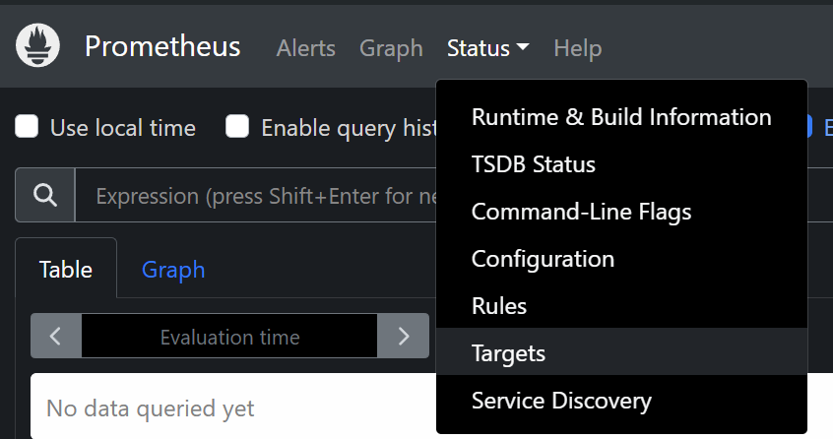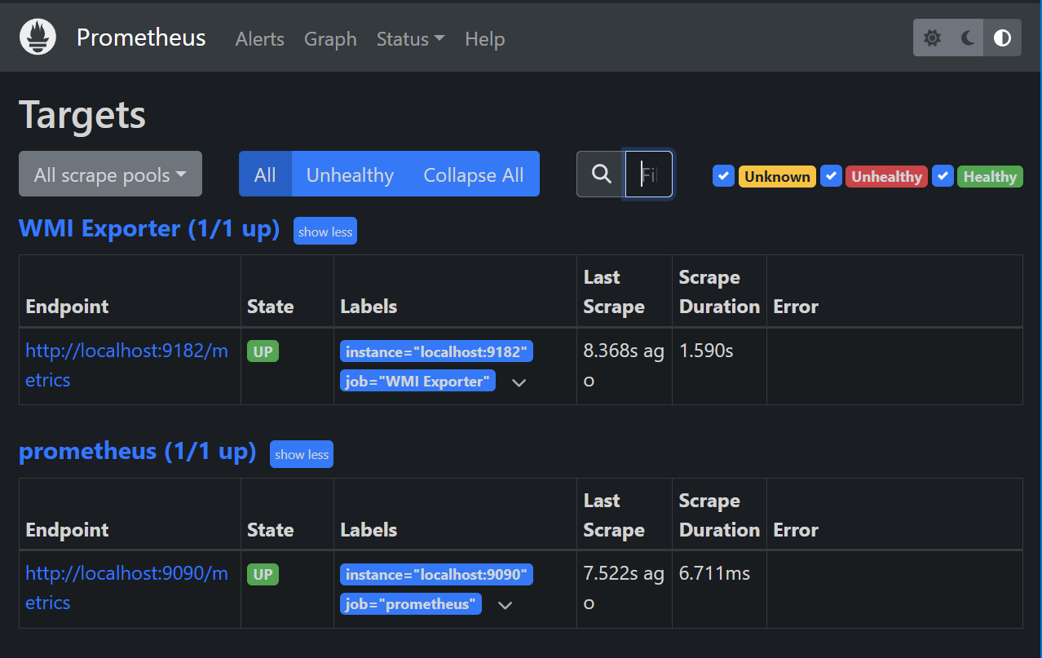

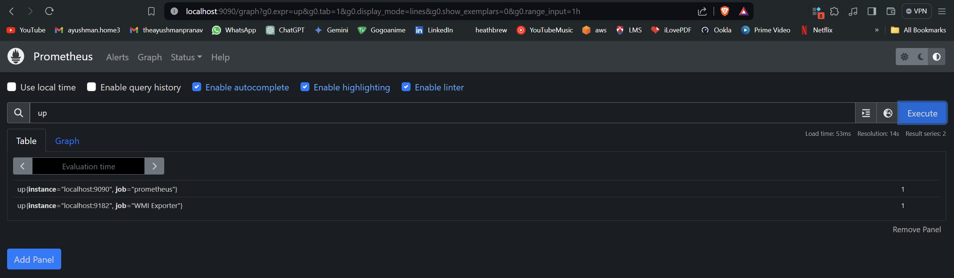

## Configuring Grafna for the metrics

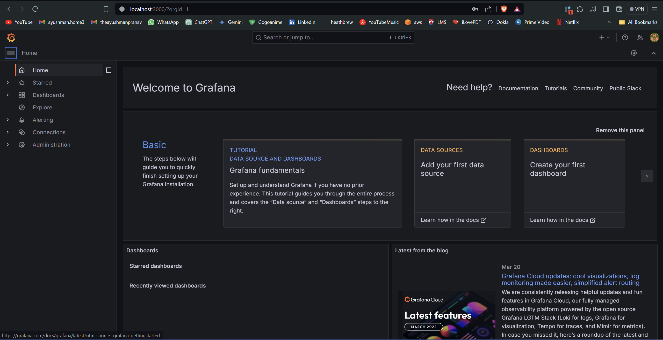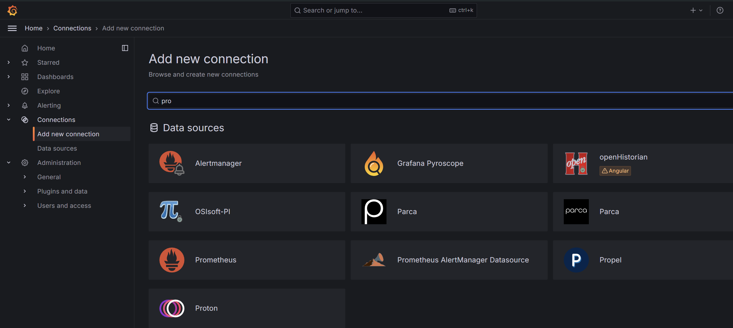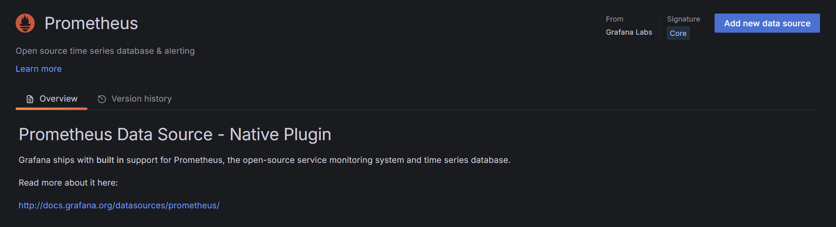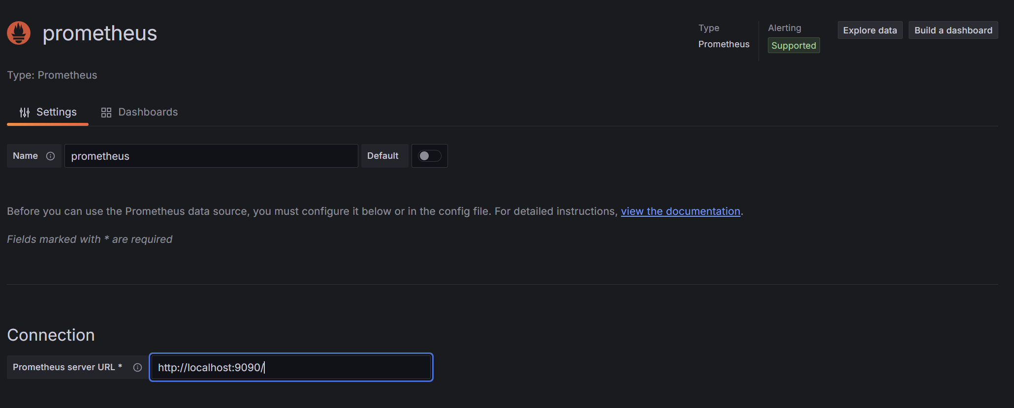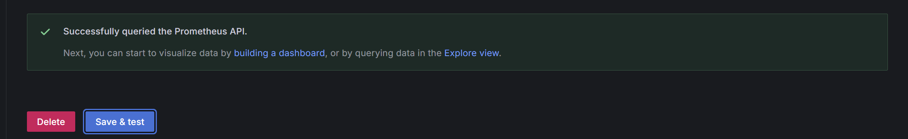

## Making the statistics Available

And run the below command to restart prometheus



**Restart the Prometheus service**



For windows dashboard URL id is 14510

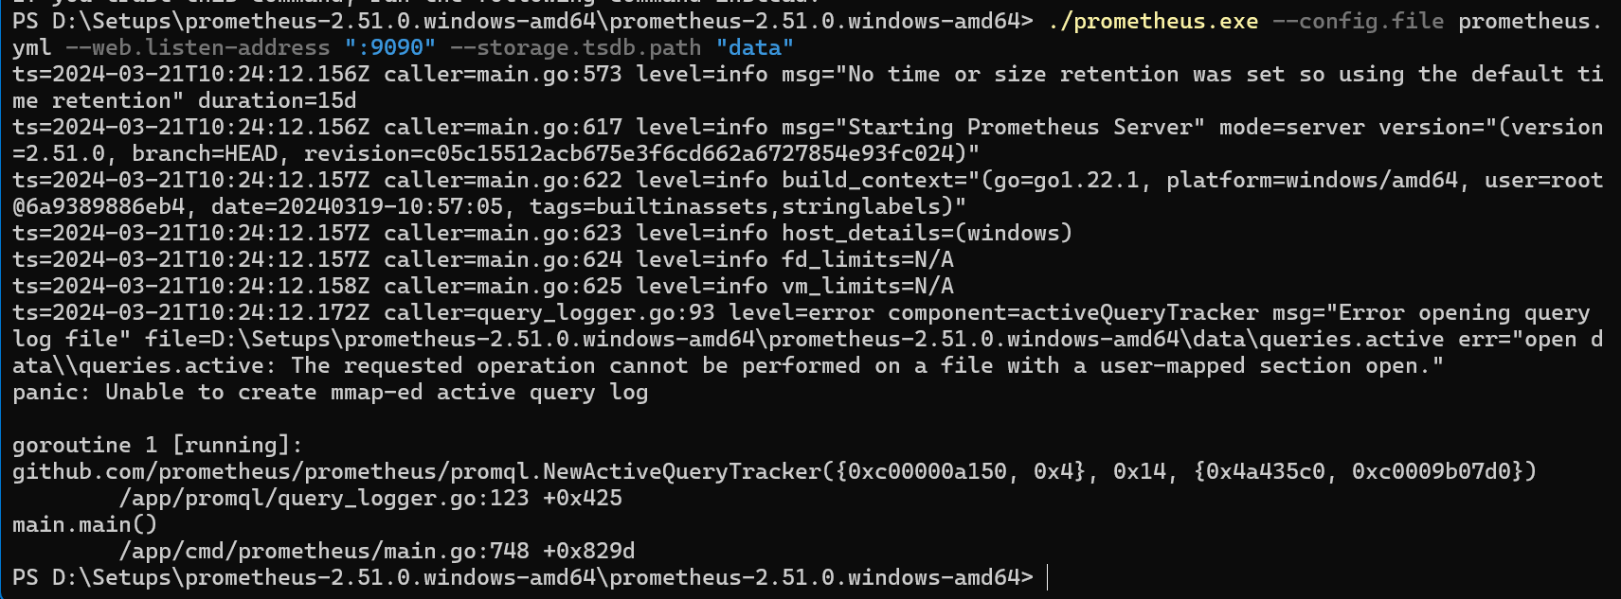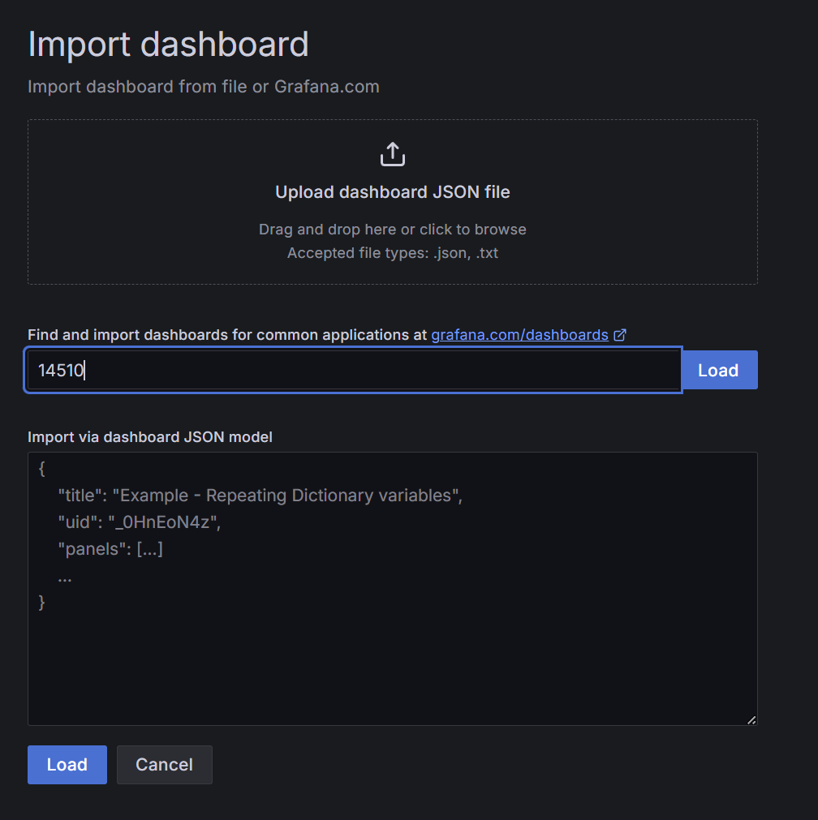

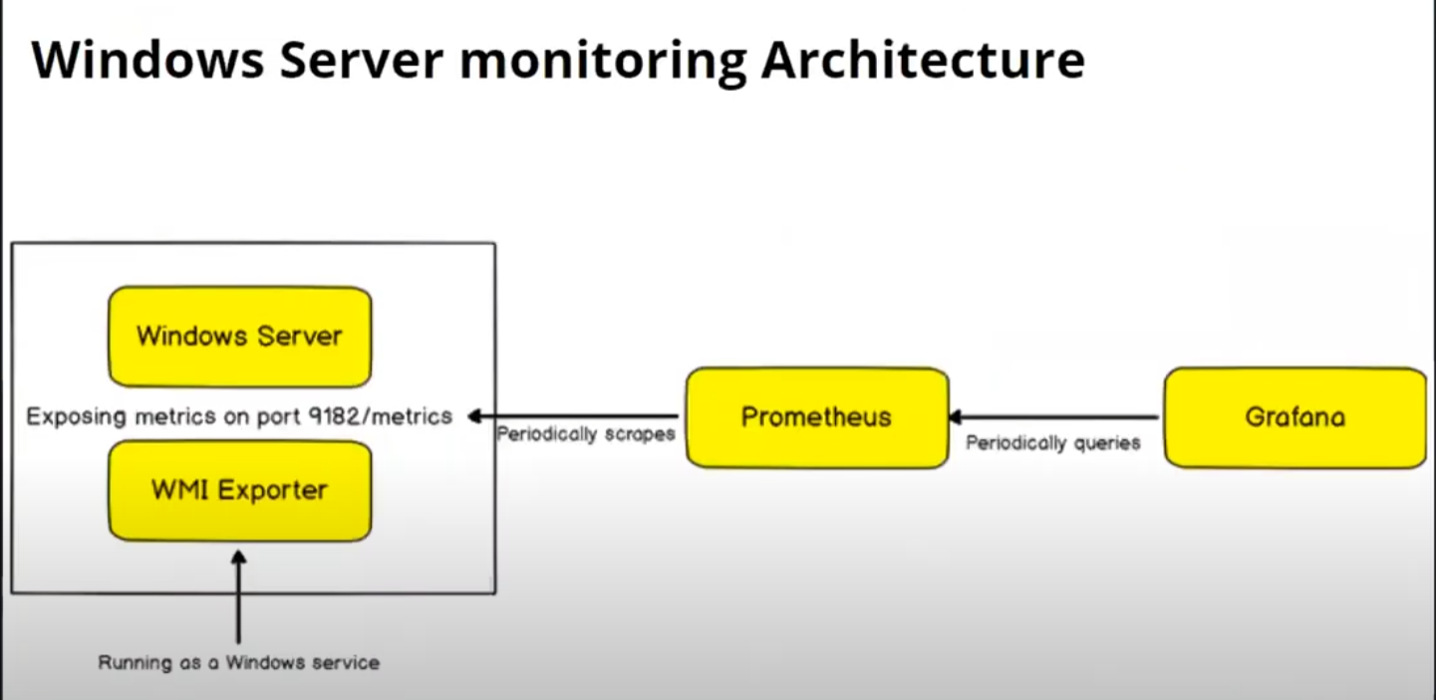

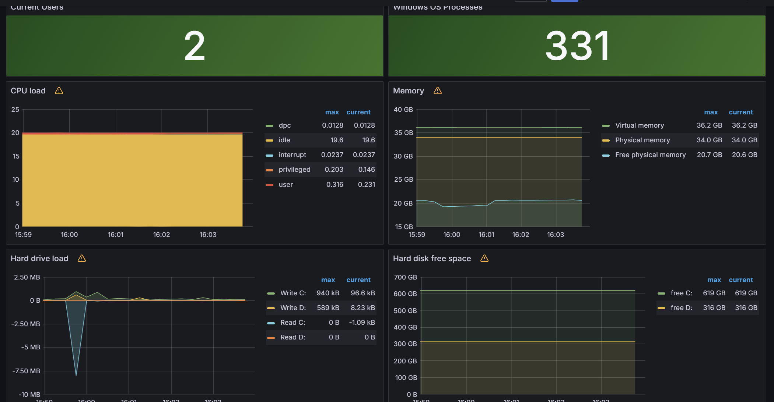

## GPU data export to Grafana

To set up the nvidia_gpu_exporter using Scoop on Windows, you can follow these steps based on the script provided on the web page you’re viewing:

1. **Install Scoop**: If Scoop is not already installed, you can install it by running the following command in PowerShell:
2. > Set-ExecutionPolicy -ExecutionPolicy RemoteSigned -Scope CurrentUser
3. > Invoke-RestMethod -Uri https://get.scoop.sh | Invoke-Expression

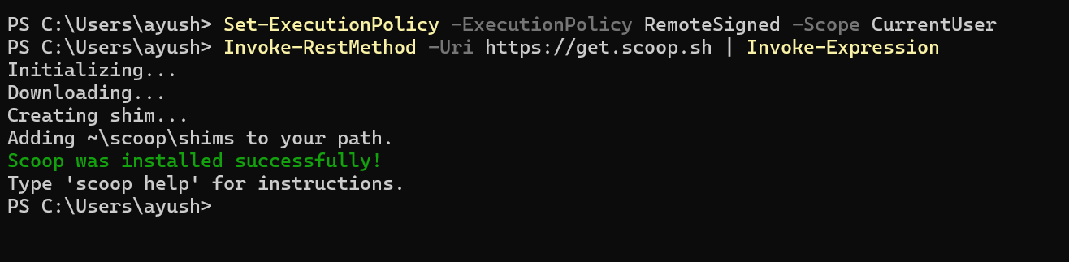

1. **Add the Extras Bucket**: Add the ‘extras’ bucket to Scoop, which contains additional apps and utilities:
2. scoop bucket add extras

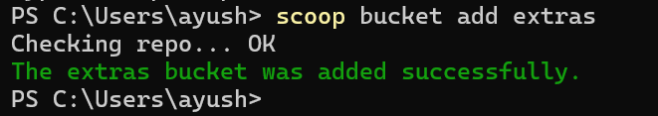

1. **Install NSSM**: Install the Non-Sucking Service Manager (NSSM) globally using Scoop:
2. scoop install nssm –global

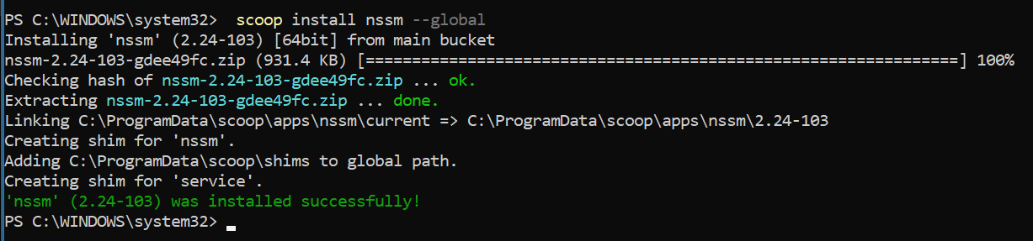

1. **Install and Set Up Nvidia GPU Exporter**: Add the nvidia_gpu_exporter bucket and install it globally:
2. scoop bucket add nvidia_gpu_exporter <https://github.com/utkuozdemir/scoop_nvidia_gpu_exporter.git>

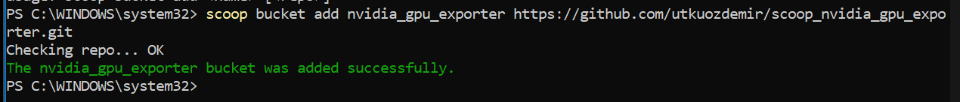

1. scoop install nvidia_gpu_exporter/nvidia_gpu_exporter –global

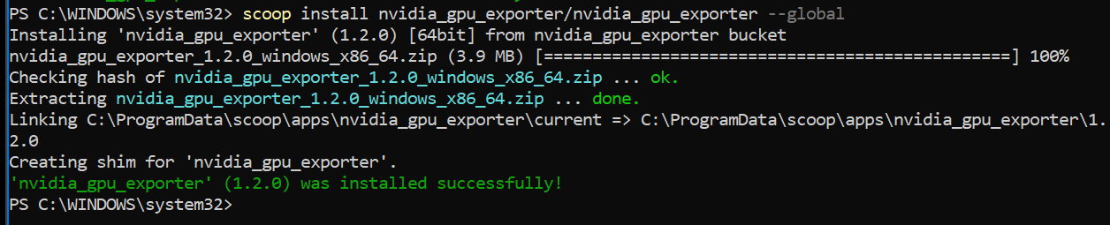

Then, use NSSM to install nvidia_gpu_exporter as a service and start it:

nssm install nvidia_gpu_exporter "C:\ProgramData\scoop\apps\nvidia_gpu_exporter\current\nvidia_gpu_exporter.exe"



Start-Service nvidia_gpu_exporter



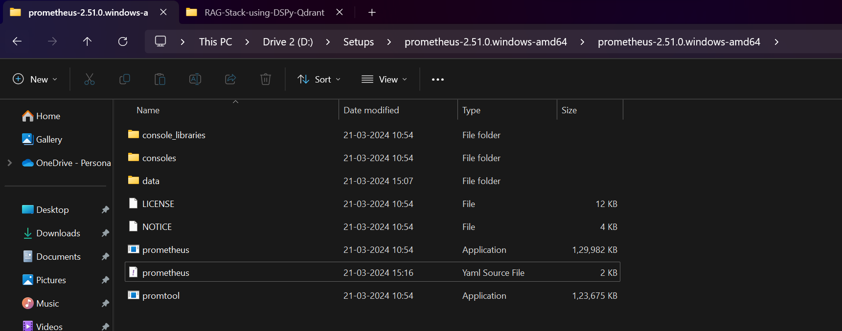

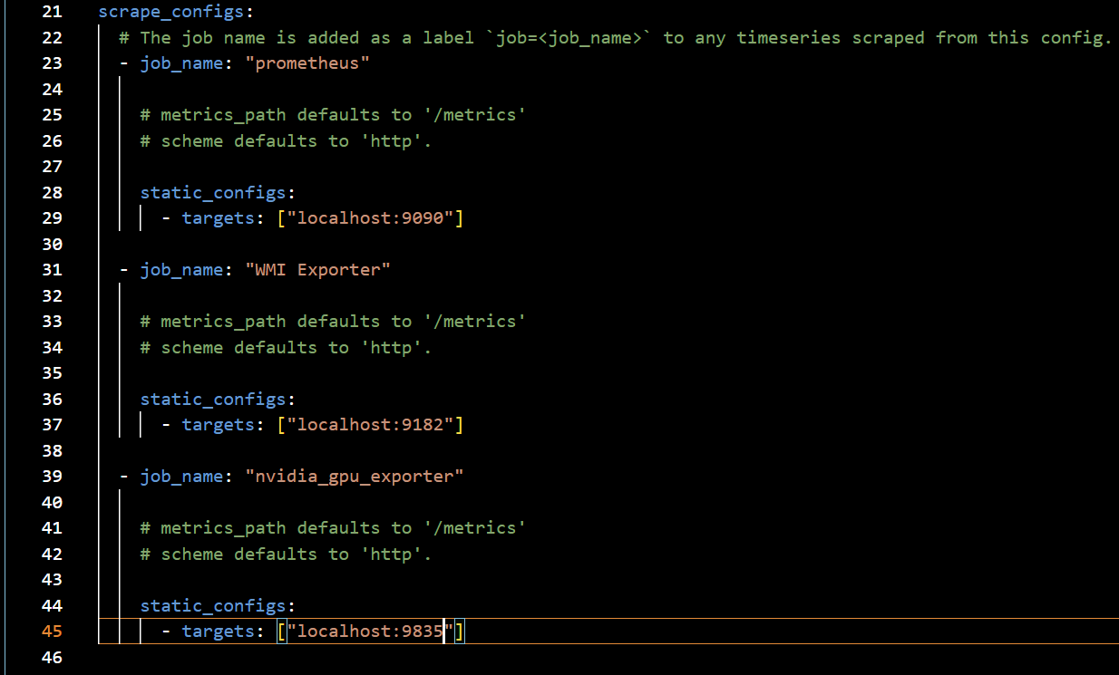



**Restart the Prometheus service**

